

*shell programming*

aSsignment -3

**SUBMITTED BY: SUBMITTED TO:**

**AYUSH KUMAR JHA Dr. Dhiviya Rose**

**SAP ID - 500086400**

**Enrollment no - R200220083**

**B.C.A -I.O.T.**

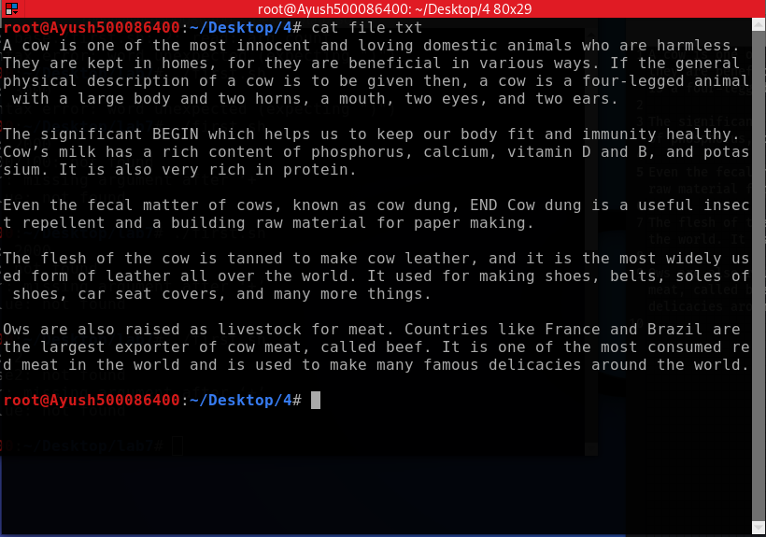

a)Write a sed command that printnumbers of lines beginning with “O”

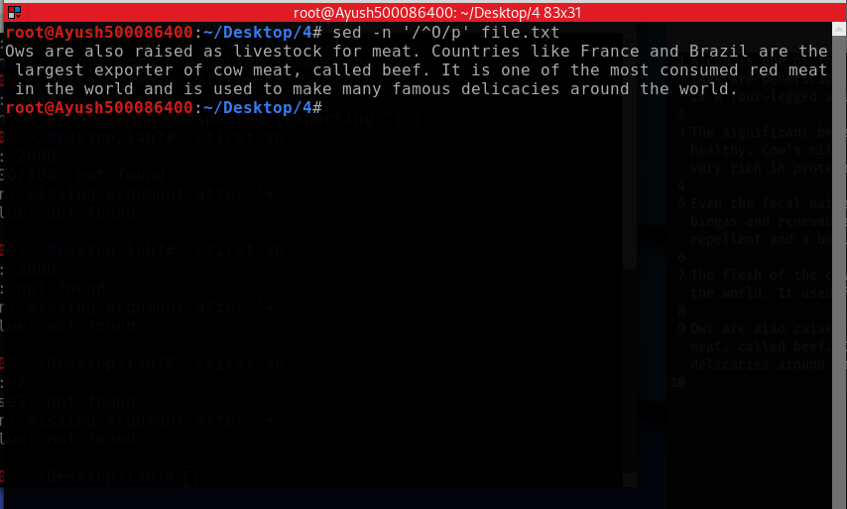

b) Write a sed command that delete lines that contain both **BEGIN** and **END**

c) Write a sed command that delete lines that contain **BEGIN** but not **END**

d) Write a sed command that deletes the first character in each line in a file